APPENDIX F: DATA FLOW DIAGRAMS (LEVEL 2)
Figures F-1 to F-8 open each of the eight processes of the level 1 diagram (Figure 4-4) into its steps, in the Gane and Sarson notation used for Figures 4-3 and 4-4. A rounded rectangle is a process, with its number in the band across the top. A rectangle open on the right is a data store. A shaded square is an external entity. Each step is one operation the system's screens perform. The stores and external entities keep the names of Figure 4-4, and each diagram uses only the stores its process uses there.
Figure F-1. Level 2 diagram of process 1.0, handle inquiries.
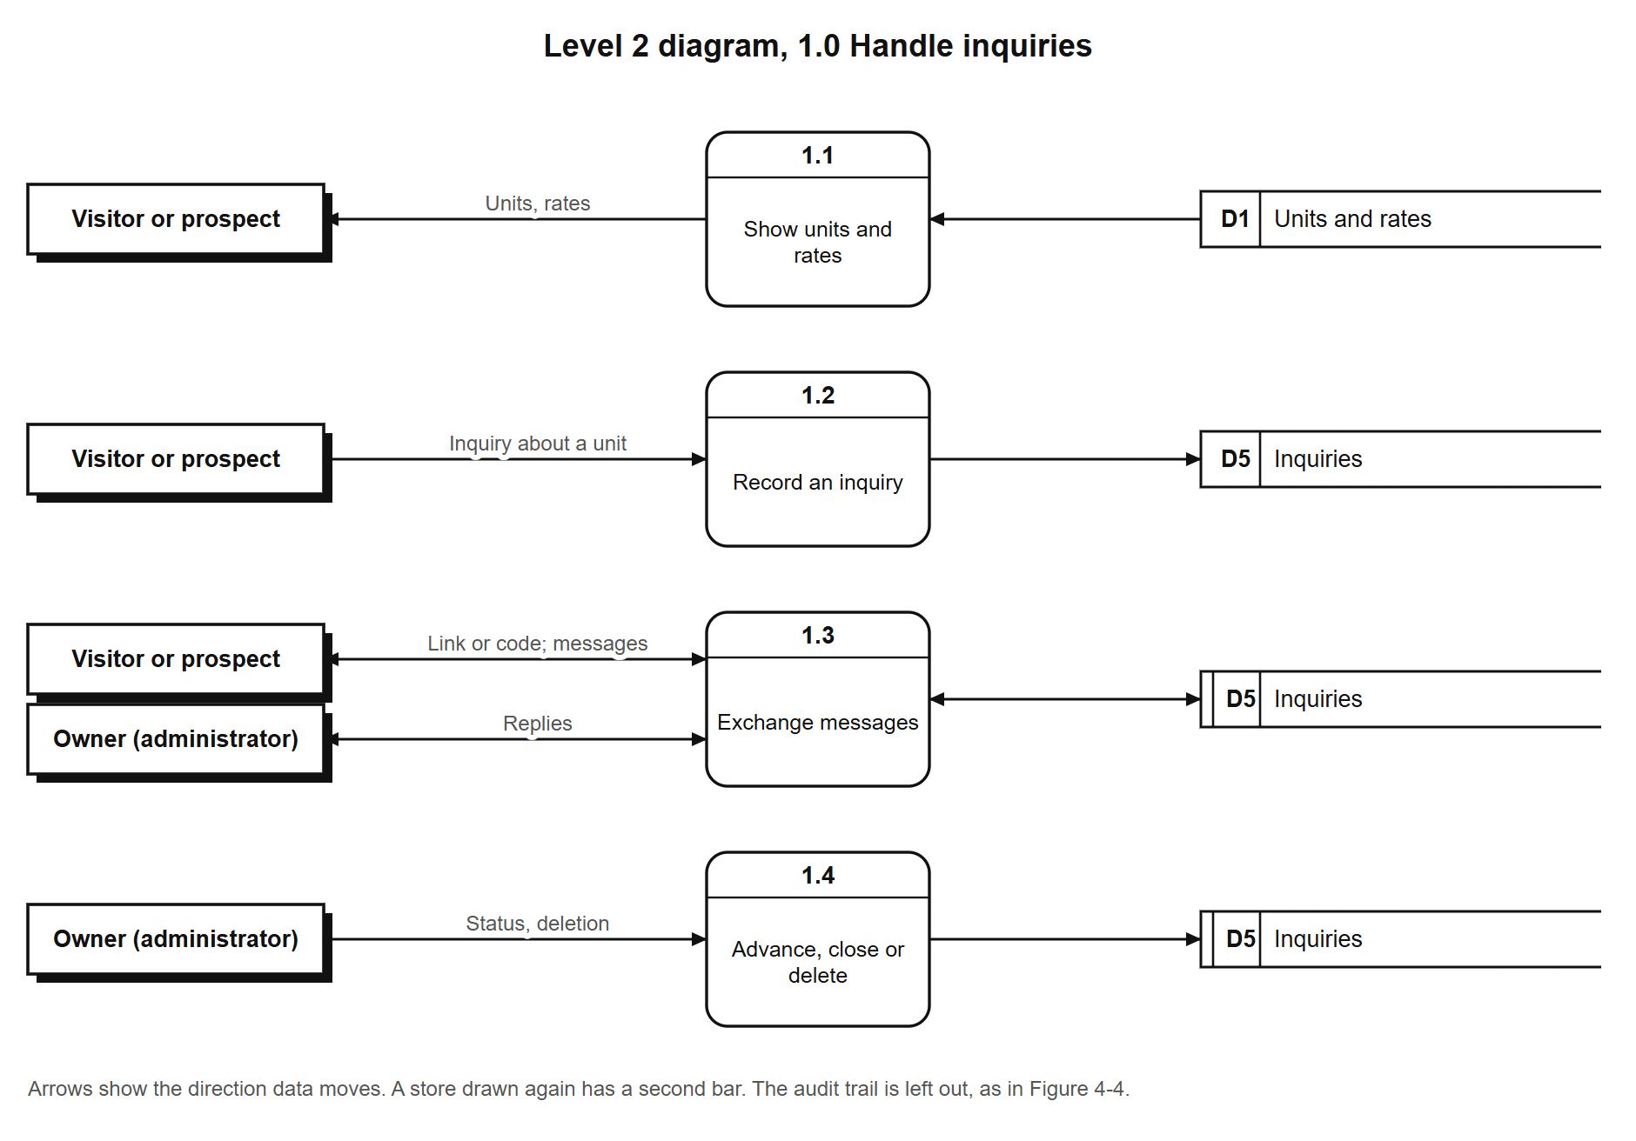
Figure F-2. Level 2 diagram of process 2.0, manage units and rates.
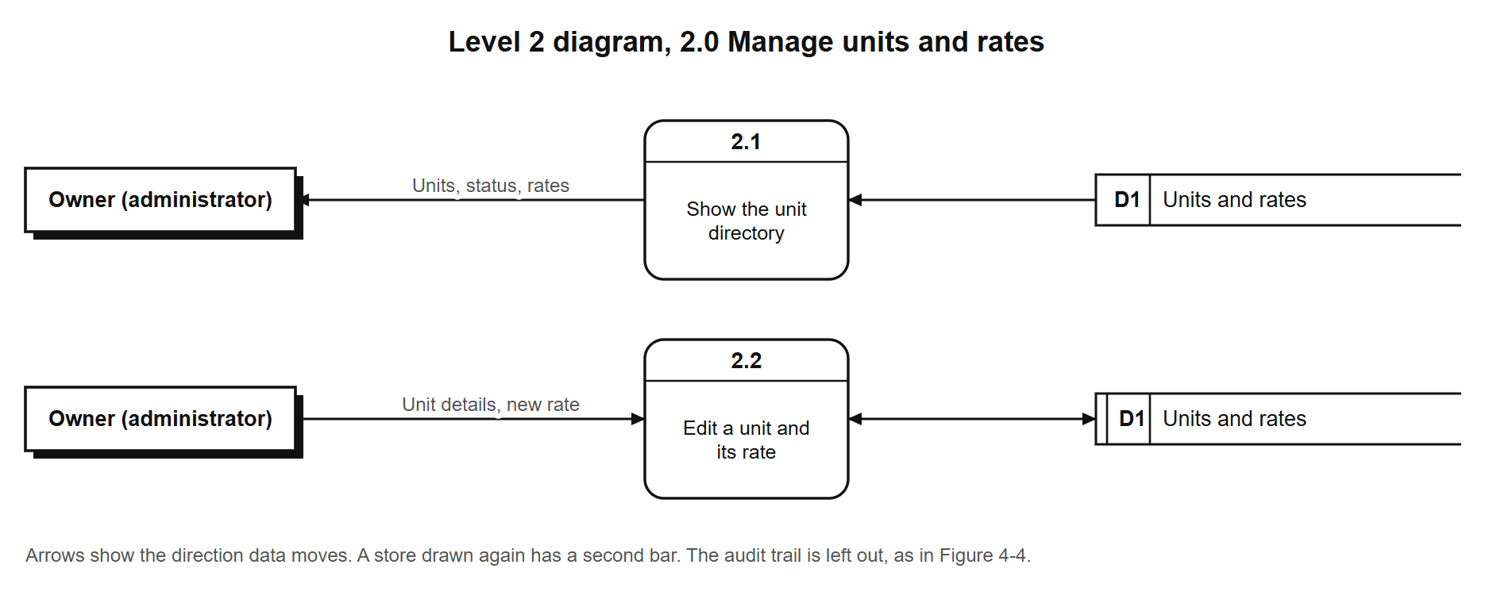
Figure F-3. Level 2 diagram of process 3.0, manage tenants and tenancies.
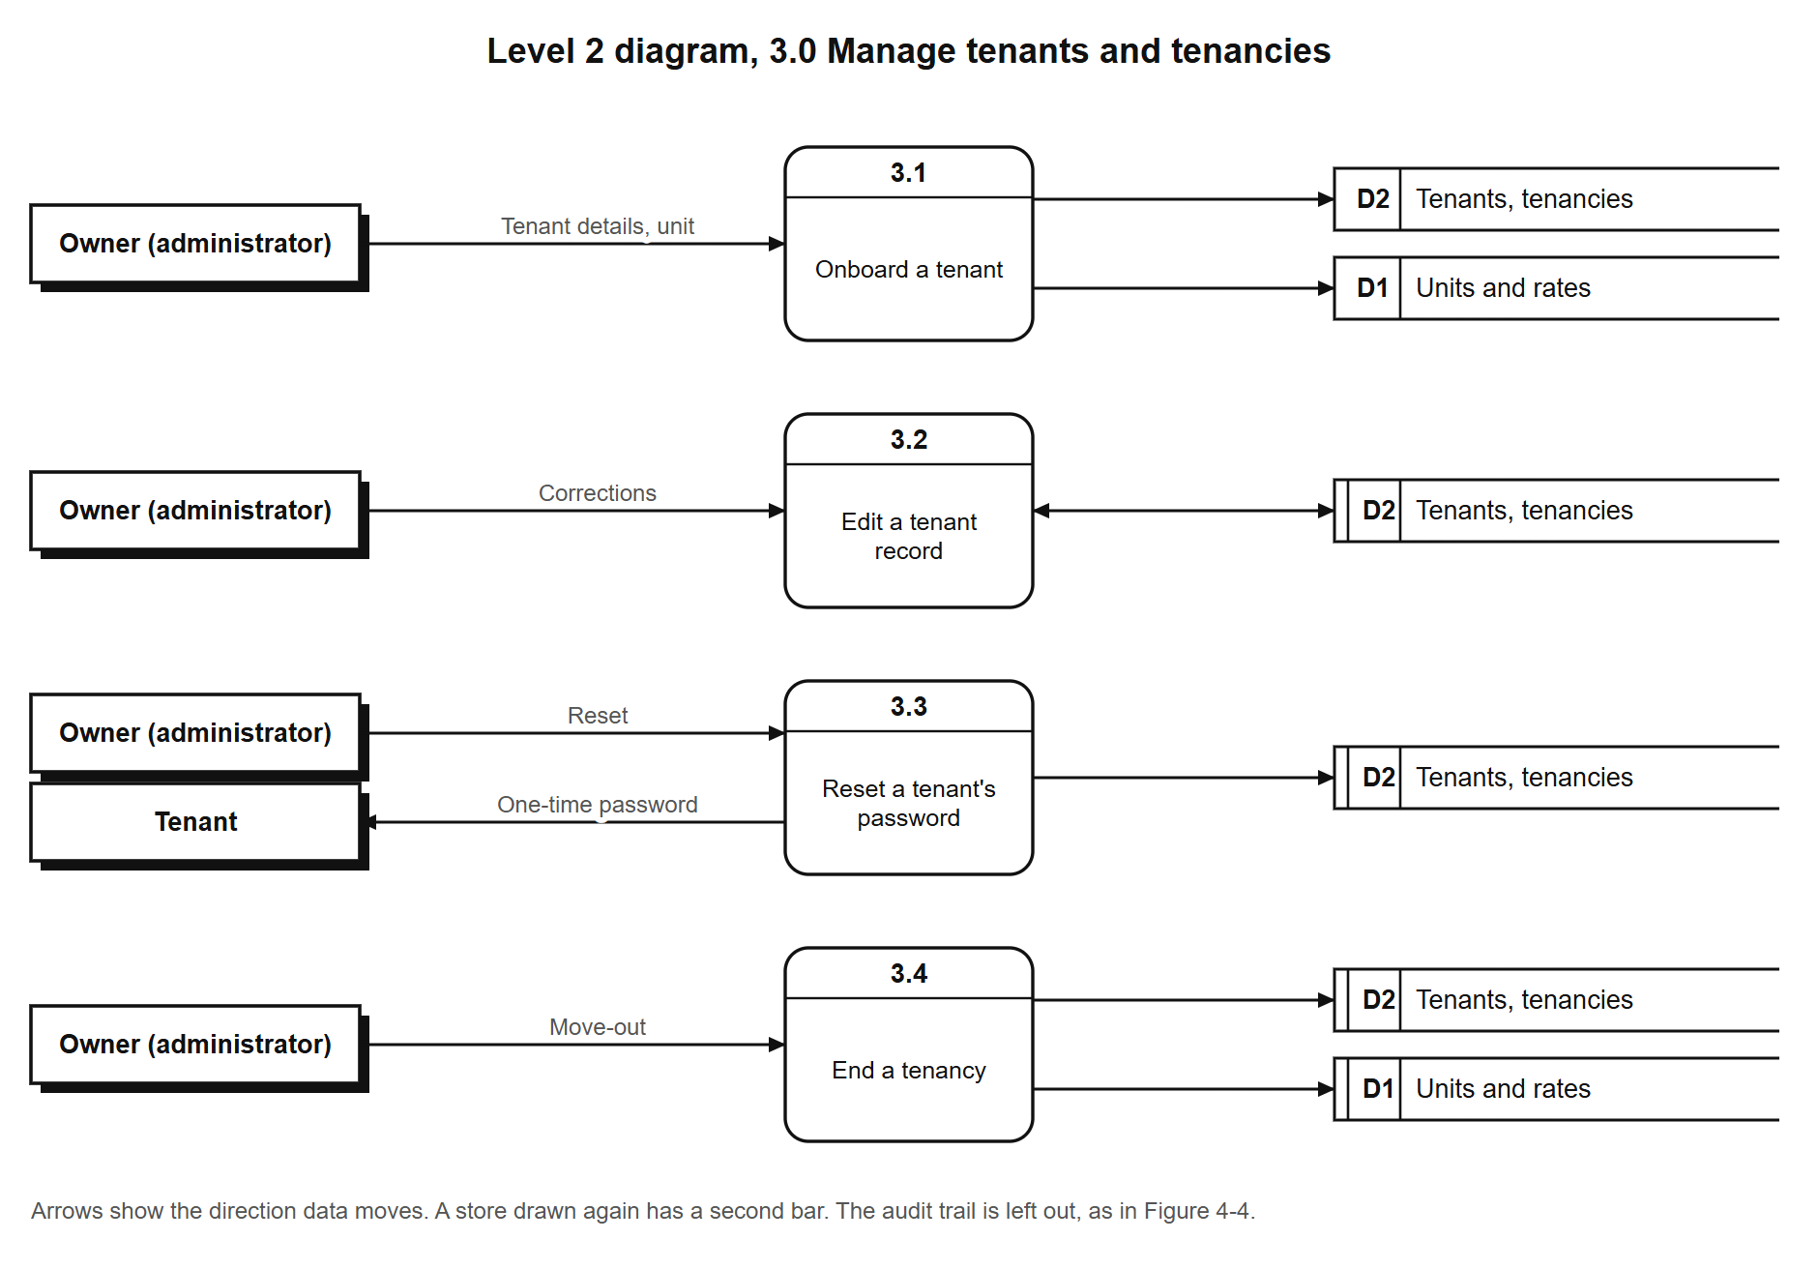
Figure F-4. Level 2 diagram of process 4.0, bill and record payments.
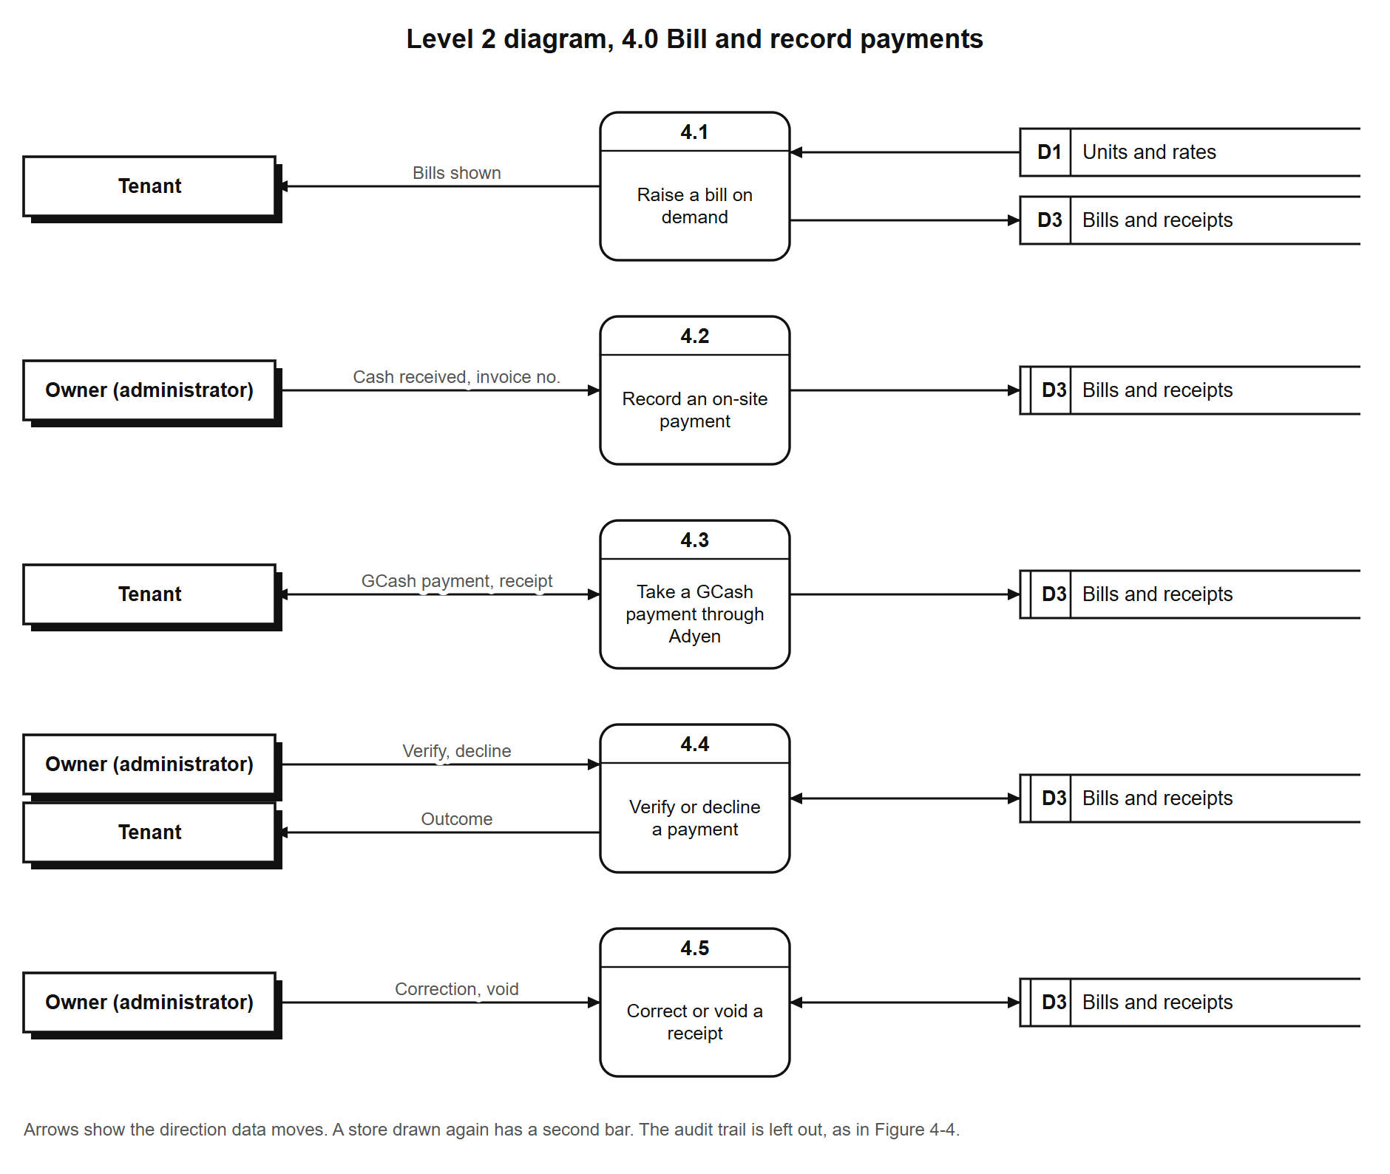
Figure F-5. Level 2 diagram of process 5.0, manage repair requests.
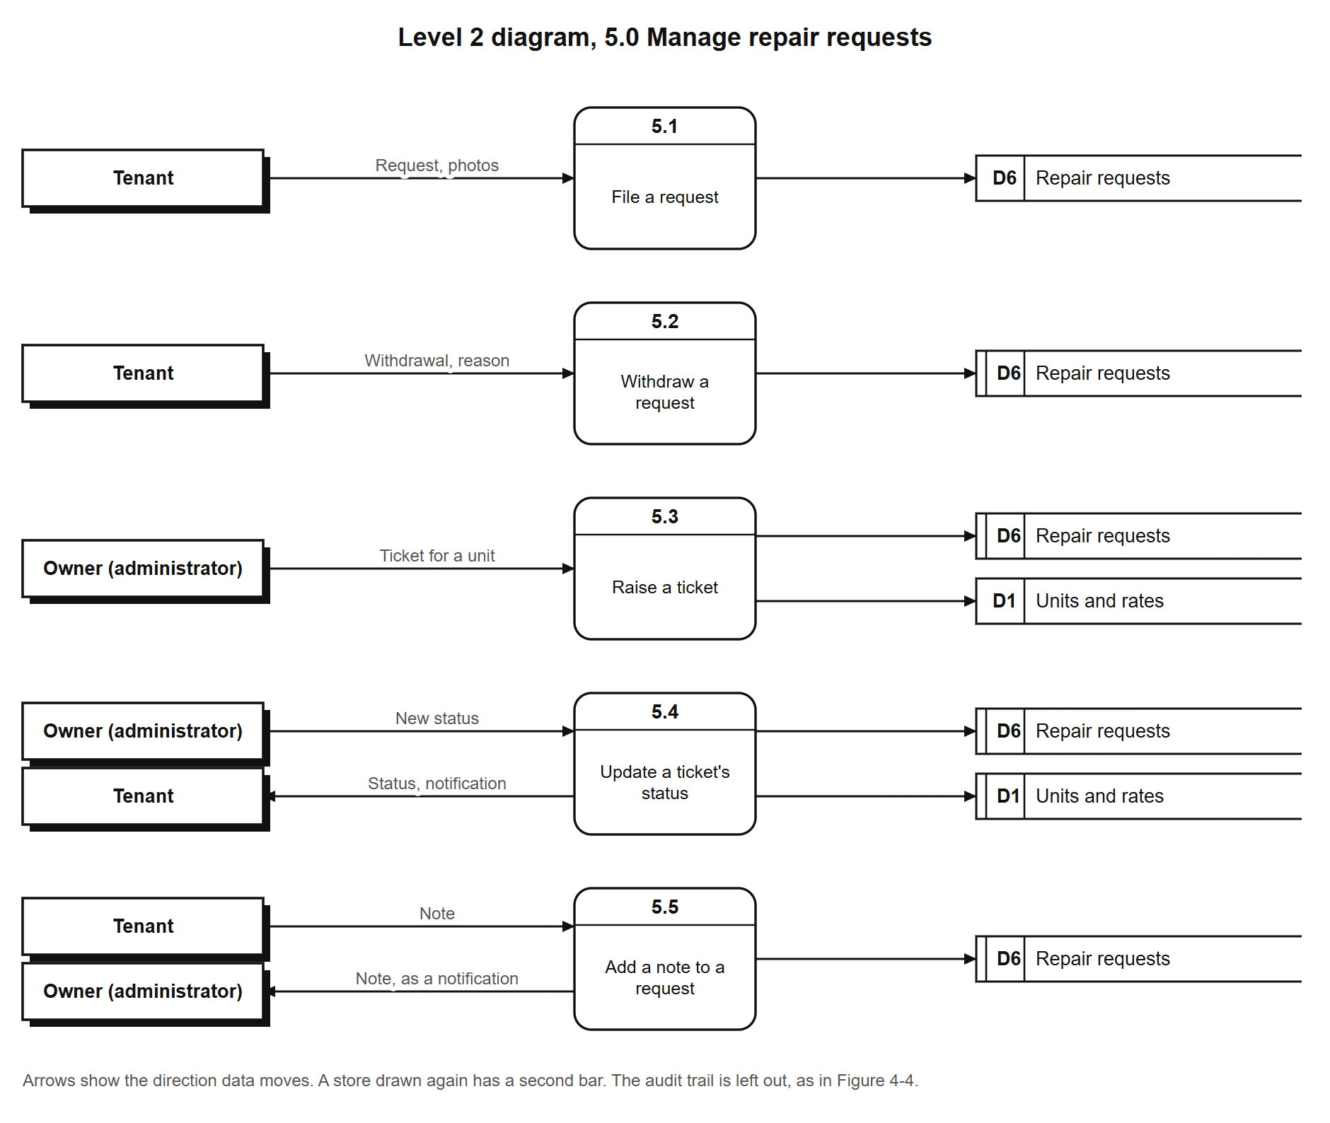
Figure F-6. Level 2 diagram of process 6.0, record expenses.
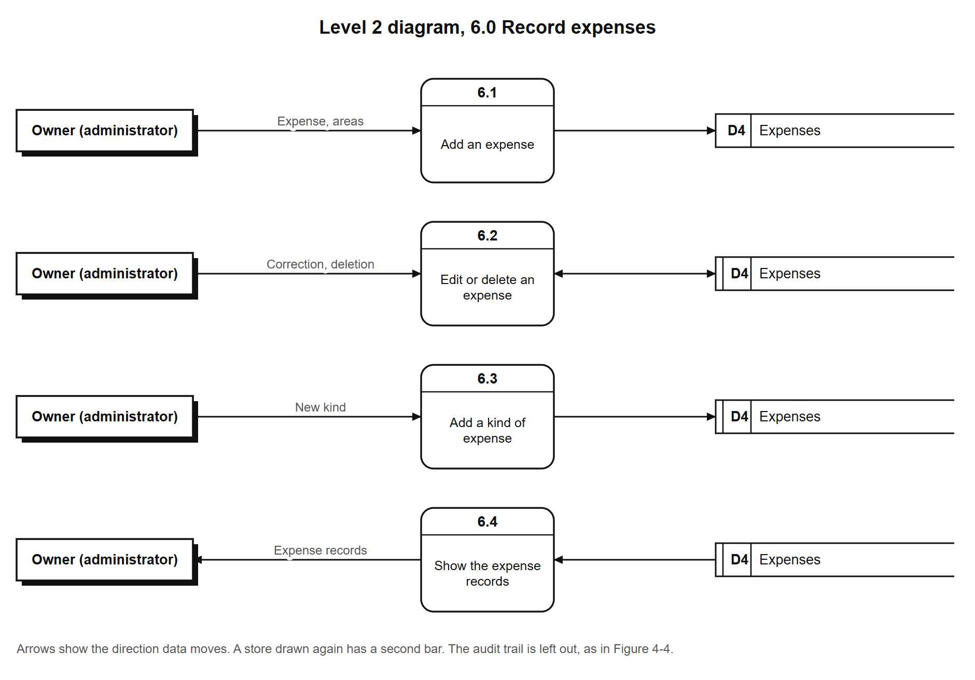
Figure F-7. Level 2 diagram of process 7.0, produce reports.
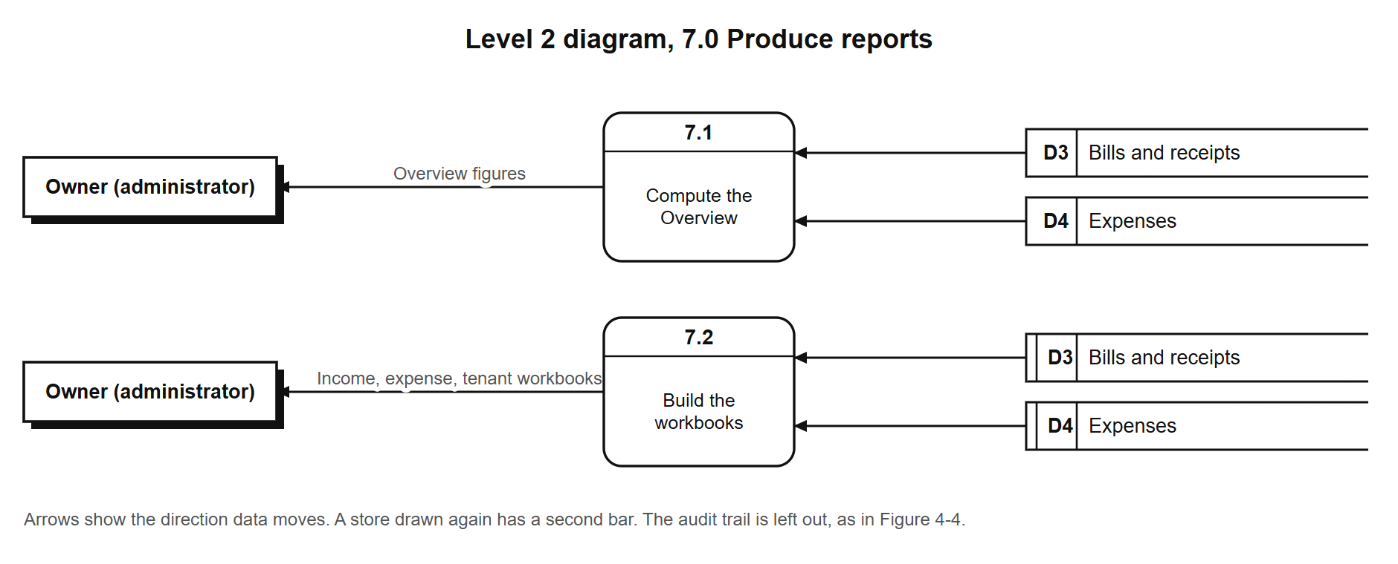
Figure F-8. Level 2 diagram of process 8.0, sign in and manage one's own account.


